Terms

Najaasate Hukmi: When a person is in need of Wudhu or bath.    
Hadas: Breaking of Wudhu or bath.    
Najis: Unclean or impure.    
Khilaal: The passing of wet fingers between the beard, fingers and toes.    
Farz: Compulsory.    
Sunnat: The practice of Hazrat Muhammad Mustafa (peace and blessings be upon him).    
Mustahab: Preferable.    
Makrooh: Disliked.    
Nawaqise: Nullify (break) Wudhu or bath.

Nijasat

Najaasat is of two types.

1. Haqeeqi – which can be seen    
   a. Ghaliza – heavy type    
   b. Khafifa – light type
2. Hukmi – which cannot be seen (HADAS)    
   a. Hadase Asghar – in need of wudhu.    
   b. Hadase Akbar – in need of bath.

**FARAAID OF WUDHU (Compulsory Acts)**

There are 4 Farz in Wudhu    
NB. If a FARDH is left out the WUDHU is INCOMPLETE.

The items that are FARDH in WUDHU:

1. Washing the FACE from the FOREHEAD to the LOWER portion of the CHIN and from one EAR LOBE to the other.    
2. Washing of BOTH the ARMS INCLUDING the ELBOWS ONCE    
3. Doing MASAH of a QUARTER of the HEAD ONCE.    
4. Washing of BOTH the FEET INCLUDING the ANKLES ONCE.

N.B. If any of the FARAA’ID are left out or a HAIRS BREADTH place is left DRY the wudhu will be INCOMPLETE.

**THERE ARE 13 SUNNATS IN WUDHU**

 If a SUNNAT is left out the WUDHU is COMPLETE but the full SAWAAB of Wudhu is not gained.

1. Niyyat (intention)    
2. Reciting of BISMILLAH.    
3. Washing of the hands thrice upto the wrists.    
4. Brushing the teeth by MISWAAK.    
5. Gargling three times.    
6. Passing water into the nostrils thrice.    
7. KHILAL i.e. to pass wet fingers into the beard.    
8. KHILAL of the fingers and toes.    
9. Washing of each part THREE times.    
10. MASAH of the whole head ONCE.    
11. MASAH of both the ears  ONCE.    
12. Wudhu done SYSTEMATICALLY.    
13. Washing of each part one after the other without pause, so no part dries up before the Wudhu is completed.

**THERE ARE 5 MUSTAHABS IN WUDHU**

 Carrying out a MUSTAHAB act brings SAWAAB or reward but no sin if left out.    
 The items MUSTAHAB in WUDHU are:

 1. To begin from the RIGHT.    
 2. To make Masah of the nape.    
 3. Not to take ASSISTANCE from anyone.    
 4. To face the QIBLA.    
 5. To sit on a high and clean place.

**THERE ARE 4 MAKROOHS IN WUDHU**

 Committing of a MAKROOH act in Wudhu causes the full BLESSING of Wudhu to be lost although the Wudhu will not have to be REPEATED.    
 The items MAKROOH in WUDHU are:

 1. To make Wudhu in a DIRTY PLACE.    
 2. To clean the nose with the RIGHT HAND.    
 3. To talk of WORLDLY AFFAIRS.    
 4. To do WUDHU against the SUNNAT.

**THERE ARE 8 NAWAQIZ IN WUDHU**

EIGHT things NULLIFY (break) the WUDHU. They are called NAWAQISE (breakers of) WUDHU.

1. Discharging of URINE, STOOL or the coming out of anything from the PRIVATE PARTS.    
2. Discharging of GASES.    
3. VOMITING in MOUTHFUL.    
4. To fall ASLEEP lying down or by resting the body against something.    
5. To FAINT due to some illness or any other reason.    
6. Becoming INSANE or going MAD.    
7. LAUGHING ALOUD whilst in NAMAAZ.    
8. FLOWING of BLOOD or MATTER from any part of the body.

**Performing Wudhu (Ablution)**

**The Niyyat (Intention)**

It is SUNNAT to make the NIYYAT for WUDHU.    
For Wudhu one should make the Niyyat at heart that I am performing Wudhu to get rid of HADASE ASGAR.    
HADASE-ASGHAR: Means the need of Wudhu.

**Wudhu (ablution)**

1. To wash one's hands, face and feet etc. before performing NAMAZ is called WUDHU or ABLUTION. No Namaaz is accepted without Wudhu.    
2. One should sit on a high and clean place to perform Wudhu. Face the direction of the Holy KA'BA Sharif if possible.

**DUA BEFORE COMMENCING WUDHU (ablution)**

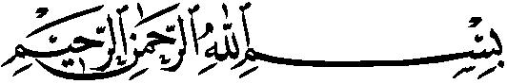

***"I begin with the name of Allah. And all praises are due to Allah."***

3. Using TAHIR (clean) water FIRST wash BOTH the HANDS upto the WRISTS THREE times.    
4. Use a MISWAAK for cleaning the teeth and then GARGLE the mouth THREE times.    
It is SUNNAT to make MISWAAK during WUDHU. By using Miswaak the reward of a NAMAAZ increases 70 times.    
5. Thereafter take water upto the NOSTRILS THREE times with the RIGHT hand and clean the nose with the LEFT hand.    
6. Then wash your FACE THREE times. Wash from the hairy part of the forehead to below the chin and from one ear lobe to the other.    
7. Then make KHILAL of the BEARD.    
8. Thereafter wash the RIGHT HAND INCLUDING the ELBOWS THREE times.    
9. Then wash the LEFT HAND INCLUDING the ELBOWS thrice.    
10. Then make KHILAL of the FINGERS.

11. Thereafter wet the hands and pass them over the head, ears and nape. This must be done ONCE only. It is known as MASAH.

**DUA WHILST MAKING WUDHU**

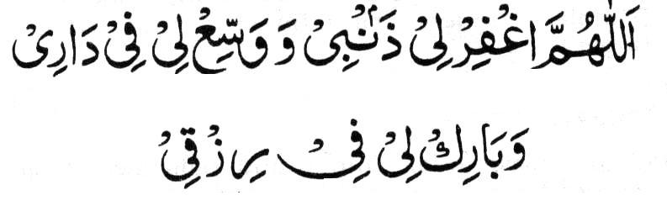

***"O Allah! forgive my sins and give expansion (abundance) in my home and grant me blessings in my sustenance."***

**MASAH**

WET THE HANDS AND FINGERS    
Keep THREE fingers of each hand together (middle finger, ring finger and little finger).    
Keep thumb and index finger raised (away).    
Keep thumb, index finger and palm away from the head.    
Pass the three fingers from the forehead to the upper portion of the nape.    
Then place the palm on the sides of the head and bring forward to forehead.    
Then insert the front portion of the index finger into the openings of the ear.    
Then make Masah behind the ears with the inner part of the thumb.    
Make Masah of the nape with the back of the middle finger, ring finger and the little finger.

12. Then wash BOTH the FEET INCLUDING the ANKLES THREE times. First the RIGHT  and then the LEFT foot.    
First wash the RIGHT FOOT including the ankle then make KHILAL and of the TOES.    
N.B. Use the LEFT HAND for KHILAL  of toes and washing of the feet.

Then wash the LEFT FOOT including the ankle and then make KHILAL  of the TOES.

**DUA AFTER COMPLETING WUDHU**

Recite Kalima Shahadat:

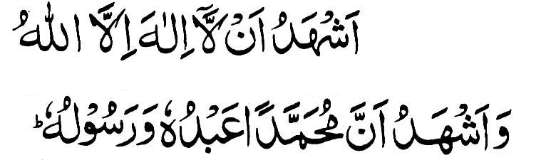

***"I testify that there is none worthy of worship but Allah, and I testify that Muhammad (peace and blessings be upon him) is Allah's Worshipper and Messenger."***

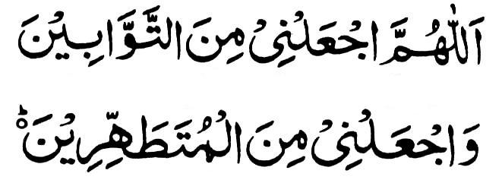

***"O Allah Make me of the repenters and make me of the purified."***

Also recite Surah Qadr.

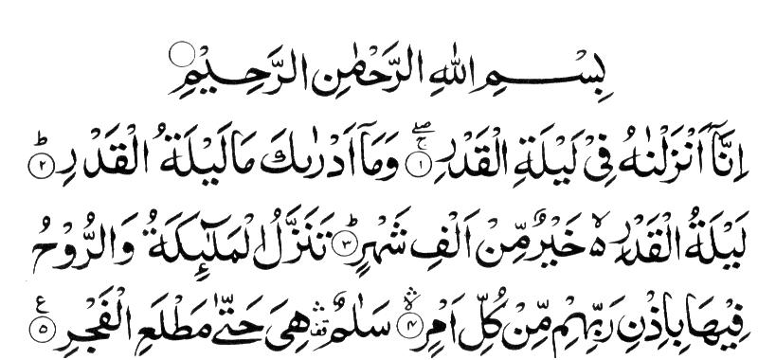

**MASAA-IL PERTAINING TO WUDHU**

1. If blood or matter does not move from the place of the wound or sore, Wudhu will not break. Wudhu will only break if the impurity flows out of the wound or sore.    
2. If clots of blood come out of the nose while blowing it, Wudhu will not break. Wudhu will only break if the blood is in the fluid state.    
3. If a pimple has to burst in the eye, then the Wudhu will only break if the fluid (that comes out of the pimple) flows out of the eye.    
4. If the blood in the saliva is more than the saliva, Wudhu will break. Therefore if one's saliva is reddish because of blood, Wudhu will break.    
5. Blood appearing on a toothpick will not break Wudhu if the effect of the blood cannot be seen in the saliva.    
6. Fluid from a paining ear will break the Wudhu, even if there is no sore or pimple in the ear.    
7. Water which flows from the eyes because of the eyes paining, will break the Wudhu.    
8. If males fall asleep in the position of Sajdah, but do not topple over, Wudhu is not broken. However, if females fall asleep in the position of Sajdah, Wudhu will break.    
9. A doubt will not break Wudhu. One remembers that Wudhu was made, but cannot remember if the Wudhu was broken. In such a case of doubt the Wudhu will be considered valid.    
10. During Wudhu one doubts whether a certain part was washed or not. In this case that particular part should be washed. However, if such doubt occurs after the completion of Wudhu, then the Wudhu will be complete. No notice should be taken of the doubt.    
11. After Wudhu if one remembers well that a certain part was not washed or Masah of the head was not made, then that part should be washed only or Masah should be made. There is no need to repeat the whole Wudhu.    
12. It is not permissible to touch the Quraan Sharif, tray, plate, etc. on which a verse of the Quraan Sharif is written or engraved, without Wudhu.    
13. It is Mustahab (preferable) to make Wudhu for each Salaat even though one may be in the state of Wudhu. It is Mustahab only if at least two Rak'aats Salaat have been performed with the previous Wudhu. Thus if one did not perform any Salaat, it will not be permissible to perform fresh Wudhu before that Wudhu has been either broken or at least two Rak'aats Salaat have been performed.    
14. If the four parts (that are Farz to be washed in Wudhu) become soaked in the rain or have been washed by swimming or taking a bath etc., then Wudhu will be valid even if one had no intention of Wudhu.    
15. While making Wudhu one should take care not to strike the water against the face causing it to splash. To do so is Makrooh.    
16. While making Wudhu the eyes should not be closed so tightly that the water is prevented from moistening the eyelashes or blocking the entry of water into the eye wells. To do so is Makroohe Tahrimi. If even one eyelash remains dry or water has not entered the eye wells, the Wudhu will be incomplete.    
17. The mouth should not be closed tightly while making Wudhu. To do so is Makroohe Tahrimi. If any part of the lips remain dry, the Wudhu will be incomplete.    
18. Wudhu will not be valid if any substance which does not allow water to seep through, sticks on any one of the four parts that are Farz to be washed in Wudhu, e.g. gum, paint, cutex (finger-nail paint), etc. If one realises after Wudhu that some gum or cutex has covered the fingernail (for example), then the Wudhu will only be valid if the gum or cutex is removed and the fingernail washed. There is no need to renew the Wudhu.    
19. If removal of the ointment from a sore or wound is harmful then it will not be necessary to remove it. If pouring water over the affected part is also harmful then merely make Masah of the affected part.    
20. If the wound or sore is bandaged and one will experience difficulty in opening and tying the bandage for Masah purpose, or Masah on the affected part will be harmful, then Masah should be made over the bandage.    
21. If this difficulty does not exist, then it will be necessary to open the bandage, plaster, etc., and make Masah on the affected part.    
22. It is best to make Masah over the whole of the upper surface of the bandage, etc. It is Wajib to make Masah of more than half the bandage, etc. If only half or less than half the bandage was covered by Masah, the Wudhu will not be valid.    
23. After making Masah if the bandage, plaster, etc., comes loose and it is realised that the affected part has healed, then the Masah made will not be valid. It will now be necessary to wash the particular part. It is not necessary to renew the Wudhu.    
24. If the beard is thick then it is not Farz for the water to reach the skin under it during Wudhu. If the beard grows sparsely so that the skin under it can be seen, then it is Farz for the water to reach the skin as well.    
25. Liquid that comes out of the eye while yawning does not break Wudhu.    
26. Finger-nails should be kept short. Dirt accumulates under long finger-nails. Wudhu and Ghusl will not be valid if the dirt is of such a nature that it does not allow water to seep through. It is also against Islamic hygiene and Tahaarat rules to keep long finger-nails and to allow dirt to accumulate under them.

**BAD ODOUR**

The odour of cigarettes, cigars, raw onions, etc. is offensive to both the Musallies and the Malaa'ikah (Angels). If one has smoked then the mouth should be thoroughly washed before entering the Masjid